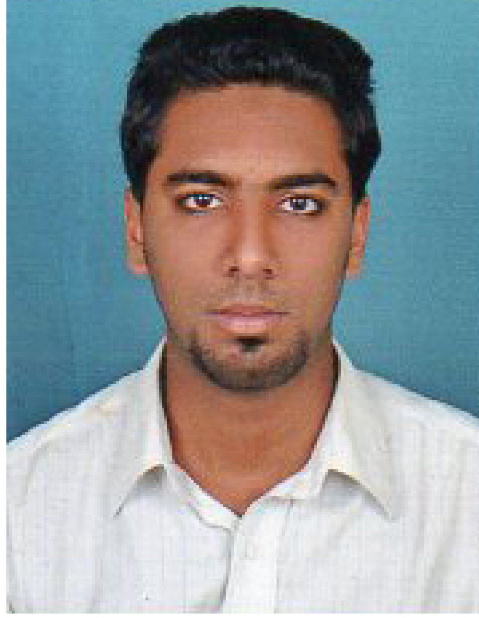
HAFSAL HUSSAIN,AUTOMOBILE ENGINEER
Puthuparambil (h)
Kanjirapally
Kottayam (dts)
Pin 686507
Mobile: +91 9633399442
Email Id: hafsalhussain312@gmail.com

Objective
To put forth the best of my abilities towards the organization, where my creative, technical
and analytical skills not only be utilized, but also be refined and sharpened through practical
applications

Educational Qualification
- B.Tech in Automobile Engineering ( 2012-2015, Anna university, India)
- Diploma in Automobile Engineering ( 2009-2012, Dote, India)

Professional Qualification
- I worked as a body shop manager at maruthi Suzuki dealership on indus motor,
India
Project Work
- I completed my project under the tittle of “AUTOMATATIC REVERSE BRAKING SYSTEM” as my under graduate mini project for qualification
- I completed my project under the tittle of “THERMAL BARRIER COATING ON
PISTON CROWN USING ALUMINIUM SILICON ALLOY” as my graduate main
project forthe academic qualification

Industrial Experience
- I completed my In-Plant training at SHAKTHI AUTO COMPONENT LIMITED,India

Technical Summary
Software | AutoCAD, Prosafe RS ,
Applications | MS Office 2003, 2007, office 2010 Package.
Operating system | Windows XP/Vista/Windows7/Windows8/Ubuntu.

Languages Known
- English, Hindi, Tamil, Malayalam
Extra Curricular Activites
- Praticipating in volley ball
- Acted as a memberin social service league in my under graduate
- Photography

Personal Skills
• Dependable and flexible to work with new technologies and concepts.
• Good leadership, interpersonal, planning and communication abilities.
• Highly inquisitive, creative, resourceful and goal oriented.
• Can be trusted to handle end-user complaints smoothly and effectively.
• Enthusiastic and committed to maintain quality and efficiency.
• Willingness to learn.
• Good team player.

Strengths
• Man management skills.
• Dedicated to hard working.
• Work well among team
• Leadership qualities

Personal Details
Gender : Male.
Marital status : Single.
Date of Birth : 02/09/1991.
Nationality : Indian.

Declaration
I declare that above information is true and fair to the best of my knowledge.

( Hafsal Hussain)

